Q1. After starting the apache server from terminal we can see the welcome page in browser.

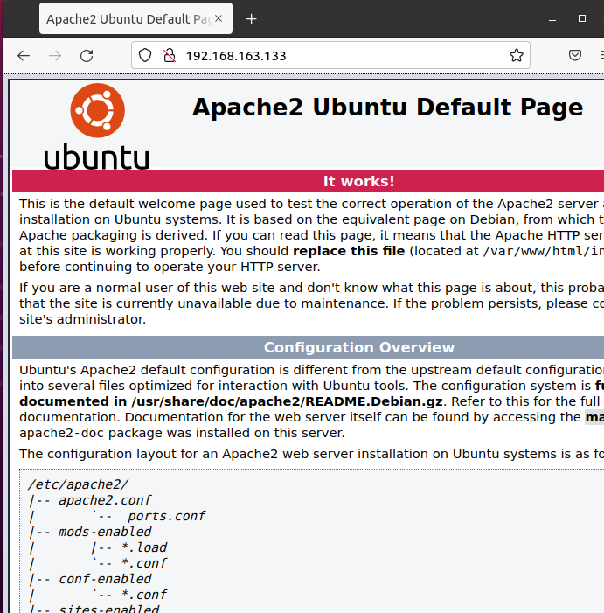

From host machine:

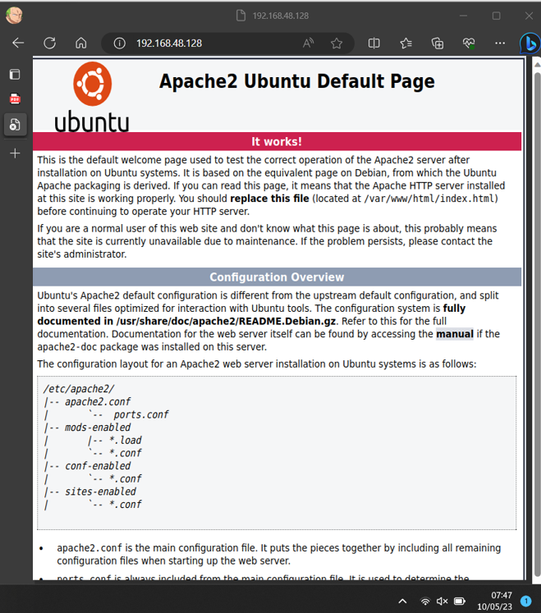

Q2.